SAML / OpenID Connect (OIDC) Token credentials
# Source: AI Source: Provided by: [Data Path: Persons Table -> ID Column: 1, Name_En Column: Motasem Essam] -> From: [ChatGPT] on [1/18/2026]
SAML / OpenID Connect (OIDC) Token credentials are tokens used for Single Sign-On (SSO) and federated authentication, allowing users to access multiple systems with one set of credentials. They are widely used in enterprise environments and modern web apps.

🔑 What Are They?
# Source: AI Source: Provided by: [Data Path: Persons Table -> ID Column: 1, Name_En Column: Motasem Essam] -> From: [ChatGPT] on [1/18/2026]
- SAML (Security Assertion Markup Language) token
  - XML-based credential issued by an Identity Provider (IdP)
  - Contains assertions about the user (identity, attributes, roles)
  - Used mainly in enterprise SSO
- OpenID Connect (OIDC) token
  - JSON-based credential built on OAuth 2.0
  - Commonly issued as ID Tokens (JWT format)
  - Used for web and mobile app authentication

Examples
# Source: AI Source: Provided by: [Data Path: Persons Table -> ID Column: 1, Name_En Column: Motasem Essam] -> From: [ChatGPT] on [1/18/2026]
SAML Assertion (XML snippet)
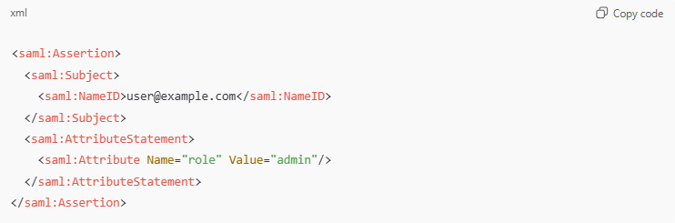
<saml:Assertion>
<saml:Subject>
<saml:NameID>user@example.com</saml:NameID>
</saml:Subject>
<saml:AttributeStatement>
<saml:Attribute Name="role" Value="admin"/>
</saml:AttributeStatement>
</saml:Assertion>
OIDC ID Token (JWT)
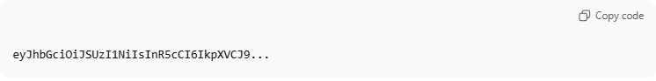
eyJhbGciOiJSUzI1NiIsInR5cCI6IkpXVCJ9...

🛠️ How It Works
# Source: AI Source: Provided by: [Data Path: Persons Table -> ID Column: 1, Name_En Column: Motasem Essam] -> From: [ChatGPT] on [1/18/2026]
- User tries to access Service Provider (SP)
- SP redirects user to Identity Provider (IdP)
- User authenticates with IdP (password, MFA, etc.)
- IdP issues a SAML assertion or OIDC ID token
- SP validates the token/assertion
- User is granted access without logging in again
Tokens assert the user’s identity and optionally their roles/permissions.

📍 Where They’re Used
# Source: AI Source: Provided by: [Data Path: Persons Table -> ID Column: 1, Name_En Column: Motasem Essam] -> From: [ChatGPT] on [1/18/2026]
- Enterprise Single Sign-On (SSO)
- Cloud services (Google Workspace, Microsoft 365, Salesforce)
- Web and mobile applications
- Federated authentication between organizations

✅ Advantages
# Source: AI Source: Provided by: [Data Path: Persons Table -> ID Column: 1, Name_En Column: Motasem Essam] -> From: [ChatGPT] on [1/18/2026]
- Users log in once for multiple systems
- Reduces password fatigue and phishing risk
- Centralized authentication and access control
- Supports attributes/roles for authorization

⚠️ Disadvantages
# Source: AI Source: Provided by: [Data Path: Persons Table -> ID Column: 1, Name_En Column: Motasem Essam] -> From: [ChatGPT] on [1/18/2026]
- Complexity in setup and configuration
- Token theft can grant access if not handled securely
- Expired or revoked tokens may cause login issues
- Depends on trusted Identity Provider

🔒 Best Practices
# Source: AI Source: Provided by: [Data Path: Persons Table -> ID Column: 1, Name_En Column: Motasem Essam] -> From: [ChatGPT] on [1/18/2026]
- Use HTTPS / TLS for all SAML/OIDC communication
- Validate signatures and expiration of tokens
- Implement short-lived tokens and refresh flows
- Limit token scopes and privileges
- Use MFA at the IdP

🧠 Authentication factor
# Source: AI Source: Provided by: [Data Path: Persons Table -> ID Column: 1, Name_En Column: Motasem Essam] -> From: [ChatGPT] on [1/18/2026]
- Something you have → token/assertion
- Often combined with something you know or something you are (MFA)

